Azure Cost Management Dashboard – Project setup

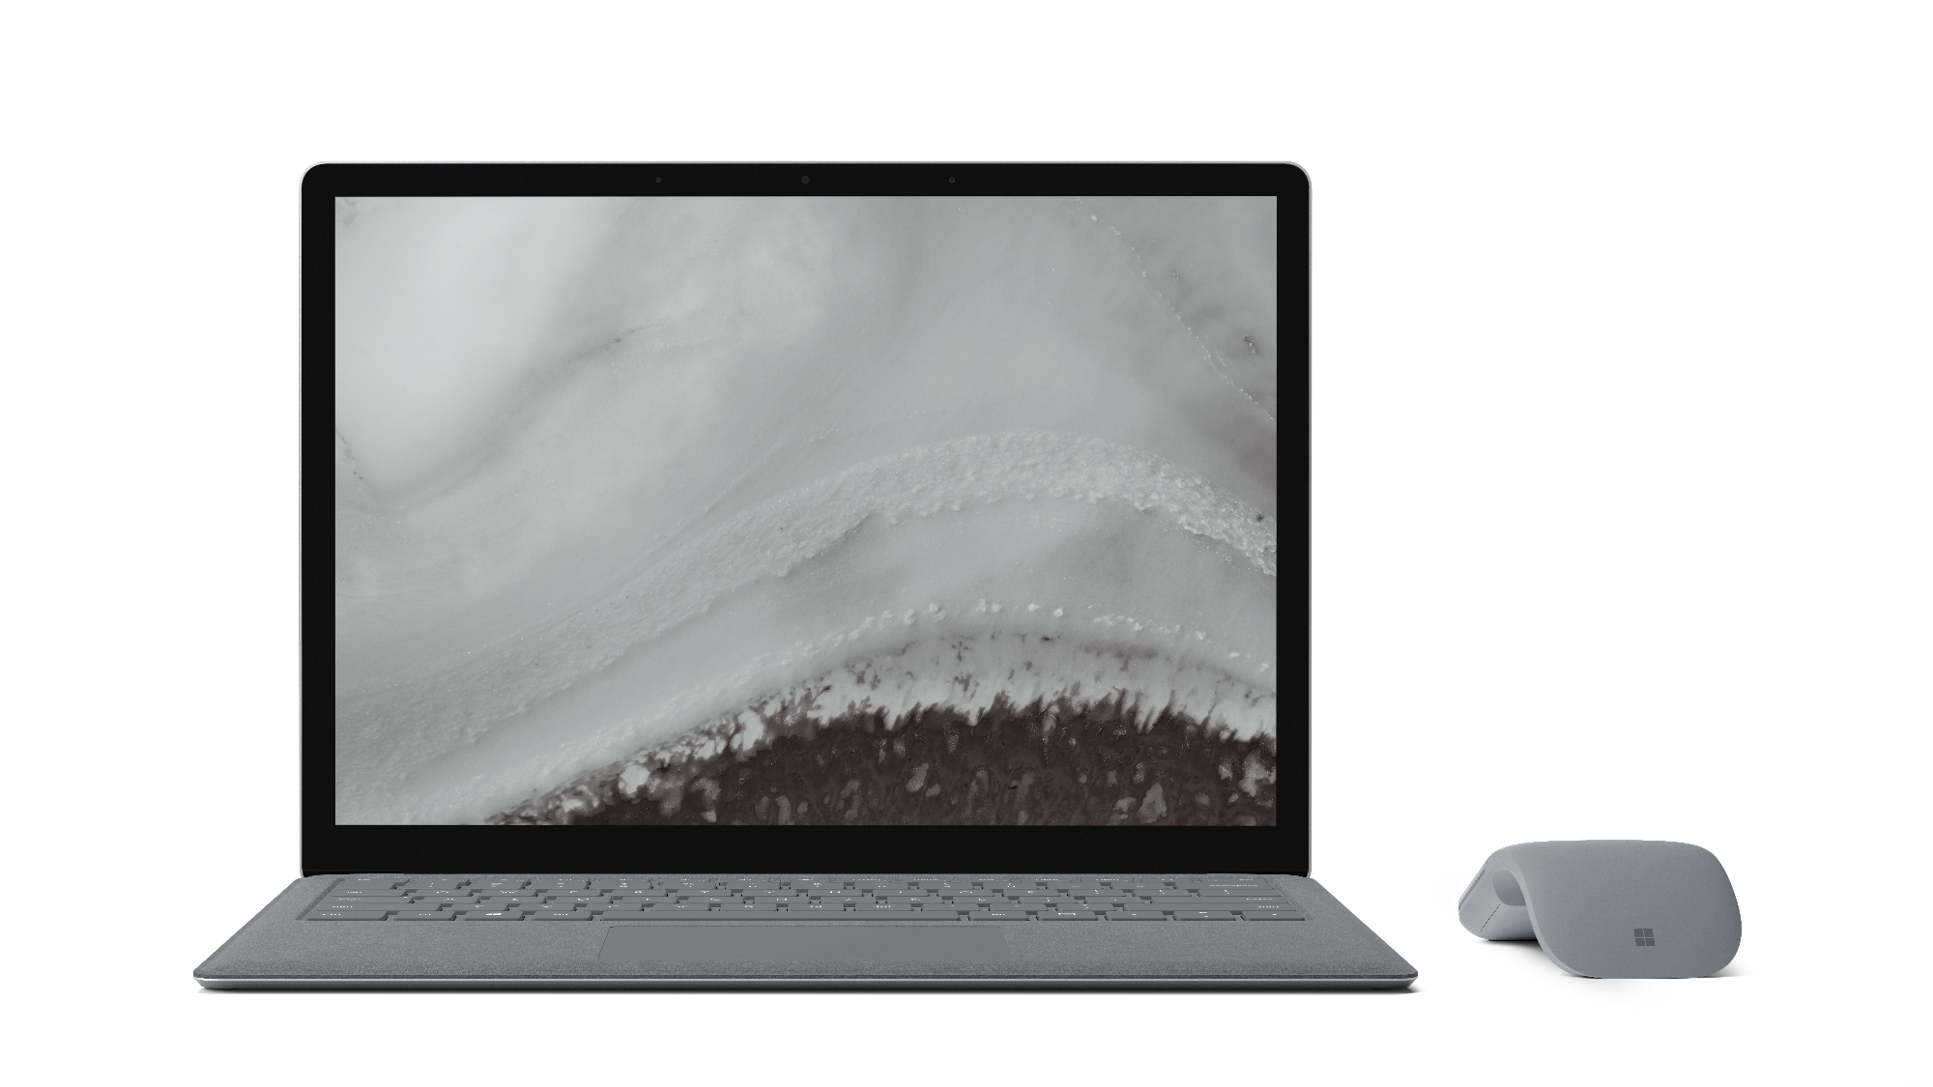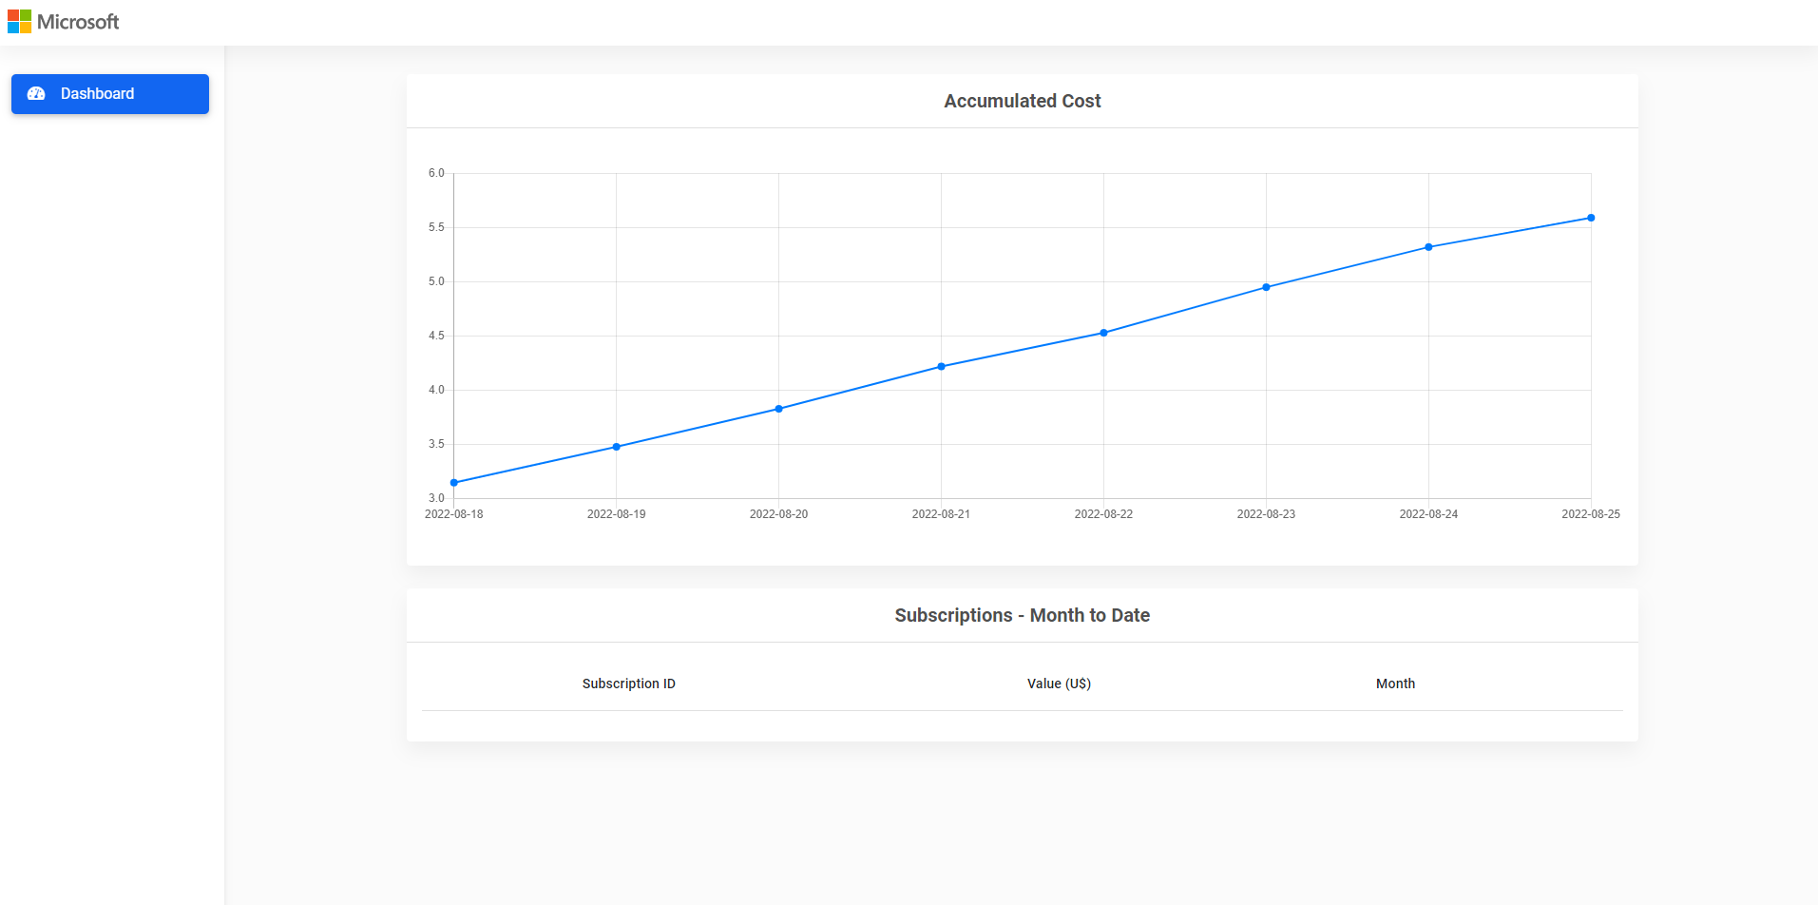

Contents

Introduction 3

Features 3

Prerequisites 3

Solution Architecture and components 4

Installation 6

Installation Steps 7

# Introduction

The purpose of this document is to detail the central idea of this Azure Cost Management Dashboard, its proposed solution architecture and the infrastructure components needed to install the system in the cloud or on-premises.

This is an open-source initiative and anyone can contribute to the source code under Github repository at <https://github.com/Azure-Samples/azure-cost-management-dashboard>

# Features

This project framework provides the following features:

* Connect to Cost Management API and get the latest subscription cost (accumulated cost monthly to date)
* Save the data into a SQL Server database
* Provide a Web Dashboard to display the latest 8 days of consumed cost per subscription

In addition to the dashboard, two background mechanisms are implemented that run cost checks and an alert via email if the current consumption exceeds a configured percentage, for example, 10% or 20%.

The Dashboard view will be through the website where the app will be installed (cloud or on-premises). The solution does not include a login option to view data.

# Prerequisites

* Visual Studio 2022 (or 2019), or Visual Studio Code
* C#
* JavaScript
* CSS
* HTML
* SQL Server (latest version recommended but not limited to)
* Azure Active Directory (install application to provide access to the subscription via REST API)

# Solution Architecture and components

Proposed architecture to the Cloud

Proposed architecture to on-premises

# Installation

The technologies involved in the solution can be downloaded from the following sources:

**Database**

* SQL Server Express: https://www.microsoft.com/pt-br/sql-server/sql-server-downloads ou
* SQL Server Basic Service Tier can be an option
* Execute scripts inside "infra" folder to create two SQL tables

**Application**

* .NET 6: https://dotnet.microsoft.com/en-us/download/dotnet/6.0

**Azure AD**

* Register an application into the Microsoft Identity Platform - <https://docs.microsoft.com/en-us/azure/active-directory/develop/quickstart-register-app>
* Add a client secret - <https://docs.microsoft.com/en-us/azure/active-directory/develop/quickstart-register-app#add-a-client-secret>
* Associate a "Reader" role to the subscriptions and include the app created previously https://docs.microsoft.com/en-us/azure/role-based-access-control/role-assignments-portal?tabs=current

# Installation Steps

### Application Configuration

Note that you will need to fill out the ***Utils.cs*** class in the solution, for that, you will need to specify the following fields:

* **TenantId**: Your Azure Active Directory`s Tenant Id
* **ClientId**: Your application ID created in Azure Active directory
* **ClientSecret**: App`s secret value
* **SubscriptionIdList**: All subscriptions that you want to get the pricing details

You will find this information under “Services” and “Utils.cs”

All other configurations related to email can be setup by yourself by providing your email from, email to, host, port and credentials (user and password).

Your **tenant ID** can be found under “Azure Active Directory” blade in the portal.

Your **ClientId** can be found after creating your application under “App Registration” blade inside “Azure Active Directory” menu.

Your **ClientSecret** can be found when you choose your app, then click under “client credentials” link:

Then, create a new client secret and use its value.

## Grant a Reader role for the app on your subscription

In order to grant permission for your application to be able to exchange data, you will need to grant a reader role for your app on your subscription.

Choose your subscription under subscription resource.

Next, add your application and assign a Reader role to it.

More information about how to add a role can be found here: <https://docs.microsoft.com/en-us/azure/role-based-access-control/role-assignments-portal?tabs=current>